**SOLAR SYSTEM DISCUSSION QUESTIONS**

**The competences in the section:**

1. *know the relative sizes, positions,*
2. *and motions of the earth, sun and moon*
3. *understand how day and night occur*
4. *and demonstrate the phases of the moon*
5. *understand the roles of the sun, earth and moon in explaining time, seasons, eclipses, and ocean tides*
6. *know the components of the solar system*
7. *and their positions*
8. *know the main characteristics of the inner and outer planets in the solar system*
9. *understand the various views about the origin*
10. *and structure of the universe*
11. Kibuuka and Kiguli were watching the English premier league match on a television at 10:00pm in the night. As they were watching, they noticed that in the pitch sunshine. Was there which indicated that it was day there other side. It confused them and they developed interest in knowing why it was like that. As time went on, the commentators said that “summer is soon ending and we are soon starting winter. People should prepare for it”. Upon hearing that, Kiguli asked Kibuuka what summer and winter means and kibuuka responded by telling him that they are seasons and that we don’t experience them here in Uganda. That left kiguli in amusement and questions what causes the two seasons and why in Uganda we don’t experience them.

Task: As a physics student,

1. Help the two people to know what causes the people in England to experience day yet in Uganda its night.
2. Explain to kiguli what causes seasons and why Uganda doesn’t experience them as told by kibuuka.
3. Ochola was reading a magazine about the solar system and landed to an article which was saying that **“………the views about the origin of the universe are very diverse and that its only big bang which tries to bring out a clear picture though leaves some questions unanswered.”** He got interested in knowing how the universe began and what big bang is. On further reading, he saw a picture showing the planets numbered from 1 up to 8 without names. Below it, was showing that the planets are categorized into inner and outer planets and each planet has unique properties which make it be in a given category. Unfortunately when he turned to the next page, the one with the explanation was missing.

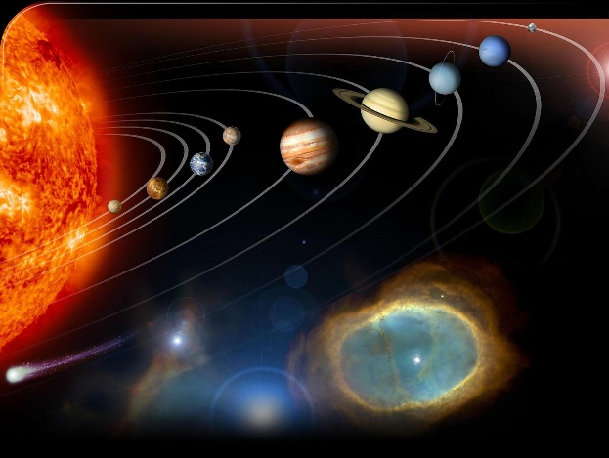

Task: As a physics student,

1. Help Ochola understanding the origin of universe by the big bang and its structure.
2. Help him
3. know the names of the planets
4. put the planets under the categories stated in the article
5. know the properties of the planets under the categories
6. know the reason to why many planets are not habitant
7. While watching a video on documentary about the oceans and their habitants, Bulgaria noticed that waters of the ocean were raising and after falls and that in some cases the rise was too much compared to others. He wondered why and asked his brother who does physics at the university but he told him that that was the ocean tides. He tried to ask for explanation but the brother didn’t know as well. This made him get interested in knowing what causes ocean tides and why some parts it’s too high yet in other parts it was low. On that same day during the night, Bulgaria looked up in the sky and observed that the moon was half yet before the night of that day, it was not half. It brought a lot of questions in his mind and concluded that may be the moon grows at some time and after it dies. When he told the same situation to a friend, the friend laughed at him and told him that the moon does not die because it’s a planet. However he didn’t know why it was like that and thus Bulgaria was not satisfied

**Task:** As a physics student,

1. Help Bulgaria understand why the waters of the ocean where raising and in some cases they are low.
2. By giving an explanation help him to get satisfied that the moon does not die and grow.
3. In the space section of a certain newspaper, various articles were published, including statements about changes in the motion of the earth, moon and sun over time, the challenges facing the solar system and ongoing exploration for habitable places in the universe. Also the size of the sun is when compared to any other planet like earth and the moon it’s strange and amazing. It can take 330000 Earths to match the mass of the sun and it would take 1.3 million earths to fill the suns volume and about 50 moons can fit the earth. The article confused any local personnel who read it to the extent that whenever two or more of the local could meet they could spent some minutes discussing that issue. Some are asking questions like “when the sun is viewed from the sky the sun is totally small compared to the earth and the moon is almost in the same size as the sun, why do they write that the sun is bigger and why that extent?”. Other arguments were on the planets which are habitant, they were wondering why spotting out the earth only to be habitable. Somewhere saying that it’s by God’s will. How does the moon, sun and earth rotate and the characteristics of the solar system.

**Task:**

Utilizing your knowledge of physics, clarify the following points for them:

1. The motion of the earth, moon and the sun.
2. The characteristics of the solar system.
3. Why earth remains the only known habitat for humans.
4. By giving a clear comparison, prove to the locals that the sun is the biggest of all the three, and if so, why is it that the sun appears to be of the same size as the moon why are they seen to be small.

Hint: $volume of a sphere =\frac{4πR^{3}}{3} where R if the radius$

$$Radius of:$$

$Earth….. 6371km$

$Sun…….695700km$

$Moon…..1737km$

1. One of the most misunderstood branches of physics for years has been space physics (Astronomy). Some of the examples of such misunderstandings include the following.

* While watching the world cup which took place in Brazil in 2014 at 9:00 pm East African time, the football fans watching the game in E. Africa realized that it was still day time in Brazil, some of them were puzzled by this.
* The NASA (National Aeronautic and Space Administration) tells us that the only planet that supports life is earth.
* The scientist belief that the universe began billion years ago and as a very small disk dust which was at a very high temperature. The theory which talks about that is the big bang.

Many people in schools and the community are in total confusion, with a lot of questions and if they meet someone who has the idea about those misunderstanding they could utilize the time and get to understand all that.

**Task:**

Make a write up explaining the above statements about the astronomical events in order to promote deeper understanding of physics in the school and community at large.

1. In a certain country, a Television (TV) reporter was reporting live near the ocean about the high tides during night time. Viewers in another country were watching the live broadcast of the news bulletin during day time. The viewers wondered how it could be day and night at the same time, and how the event in one country could be watched live on TV in another country.

Task

Using your knowledge of physics to help the viewers to understand;

1. The possibility of it being day in one place and night in another place.
2. The occurrence of High Ocean tides.
3. How an event in one place can be broadcast live in another country
4. **The solar system is composed of big, small and much smaller objects including planets. All planets move around the sun in elliptical paths. The motion is both rotational and revolution. Rotation motion involves the planets spinning about a fixed axis and revolution motion involves planet moving around**

**Task:**

1. **Identify the other components of the solar system.**
2. **Which name is given to the path in which planets move?**
3. **Draw diagrams to show rotational motion and revolution motion of the planets.**